**Ideation phase**

**Define the problem statements**

|  |  |
| --- | --- |
| Date | 28 september 2023 |
| Teamid | Proj-212176 team-1 |
| Project Name | Ai based diabetes prediction system |
| Maximum marks |  |

**Customer problem statement template:**

* We discuss the use of AI in medicine for diabetes, specifically in medical devices. The first AI-based medical device, BodyGuardian, was cleared by the US Food and Drug Administration (FDA) in 2012 when approval was given to a patch-like electrocardiogram equipped with an AI-based arrhythmia detection algorithm. Since then, the regulations on programmed medical devices, including AI, have advanced in various countries, including the USA, Europe, China, and Japan. Thanks to the outstanding development of deep learning technology and advancements in clinical applications these days, the number of approved AI-based medical devices has dramatically increased in both the USA and Europe in the past few years
* Currently, there are dozens of FDA-cleared AI-based medical devices using AI/machine learning technology. While most of these approvals are linked to radiology, cardiology, and oncology, three AI-based medical devices are related to diabetes management [[5](https://www.ncbi.nlm.nih.gov/pmc/articles/PMC8668843/#CR5)•]. In Japan, 12 types of AI-based medical devices have been approved as of 2020. However, all of them are for image analysis concerning radiology and diagnostic imaging, and there are no such medical devices approved for diabetes care.
* Efforts towards the clinical application of AI in the diagnosis and treatment of diabetes are mainly categorized into four areas: (1) automatic retinal screening, (2) clinical diagnosis support, (3) patient self-management tools, and (4) risk stratification [[6](https://www.ncbi.nlm.nih.gov/pmc/articles/PMC8668843/#CR6)]. The first category is automatic retinal screening, an AI technology that automatically interprets the presence or absence of diabetic retinopathy—an important complication of diabetes—from fundus images. An example of this technology is the IDx-DR device manufactured by Digital Diagnostics Inc., approved by the FDA in 2018 for its high diagnostic performance by clinical trials [[7](https://www.ncbi.nlm.nih.gov/pmc/articles/PMC8668843/#CR7)]. Using this AI device, patients can be diagnosed with diabetic retinopathy or not without professional judgment from an ophthalmologist. Then, primary physicians can choose to have the patients with their fundus images see an ophthalmologist or re-examine the IDx-DR device 12 months later. This device facilitates the screening and diagnosis of diabetic retinopathy, especially in rural communities where patients have difficulties accessing an ophthalmologist

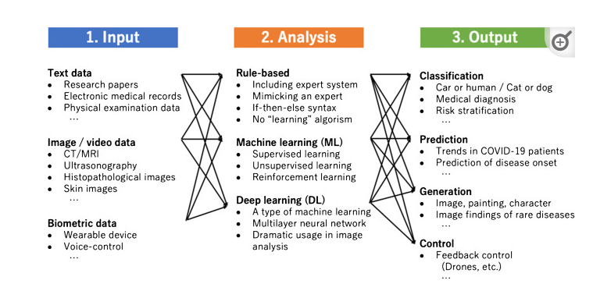

**Ideation phase**

**Empathize&Discover**

**Empathy map canvas:**

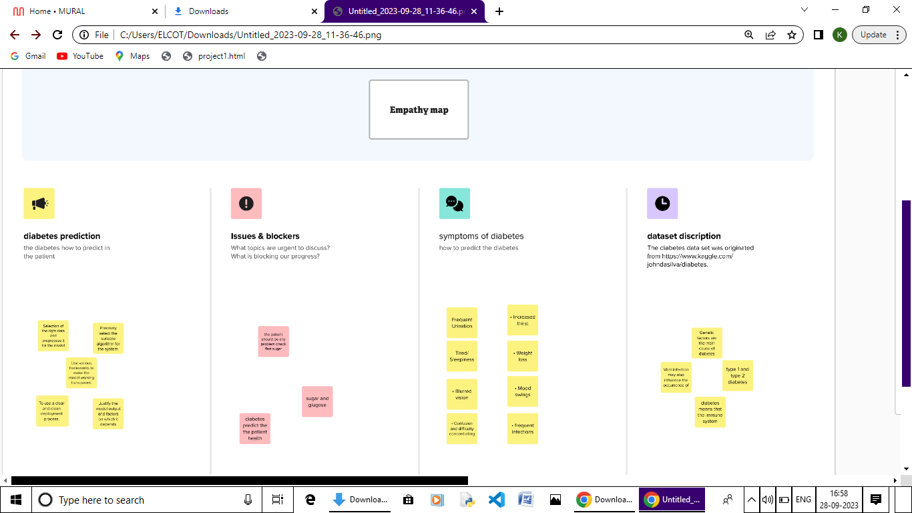

In this section we shall learn about the various classifiers used in machine learning to predict diabetes. We shall also explain our proposed methodology to improve the accuracy. Five different methods were used in this paper. The different methods used are defined below. The output is the accuracy metrics of the machine learning models. Then, the model can be used in prediction.

**Dataset Description:**

The diabetes data set was originated from https://www.kaggle.com/johndasilva/diabetes. Diabetes dataset containing 2000 cases. The objective is to predict based on the measures to predict if the patient is diabetic or not

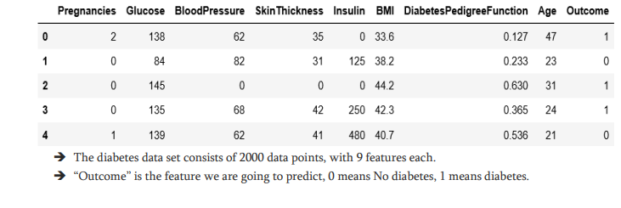

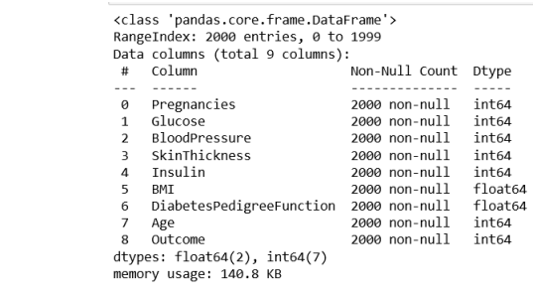

**METHODOLOGY :**

In this section we shall learn about the various classifiers used in machine learning to predict diabetes. We shall also explain our proposed methodology to improve the accuracy. Five different methods were used in this paper. The different methods used are defined below. The output is the accuracy metrics of the machine learning models. Then, the model can be used in prediction.

**Symptoms of Diabetes:**

• Frequent Urination • Increased thirst

• Tired/Sleepiness • Weight loss

• Blurred vision• Mood swings

• Confusion and difficulty concentrating • frequent infections